# **Isaiah**

Dr. Marvin J. Effa, 2024

**Isaiah**

**Author**: Isaiah wrote all of Isaiah. The New Testament attributes both sections of Isaiah to Isaiah (Jn. 12:37-41 quotes Isa. 6:9-10 and Isa. 53:1).[1] Furthermore, the argument of Isaiah fails if it is not a single author.

**Date of writing:** 740–680 B.C. 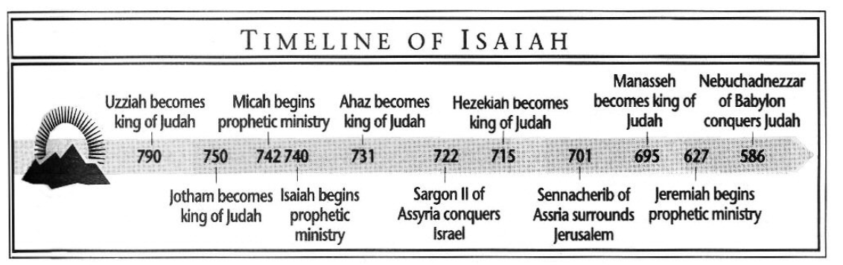

**Purpose**: To prove that no idol can bring people and nations to judgment, provide salvation, and predict the future.

**Idea**: The judgment and punishment of God upon sin makes the Messiah’s salvation of Israel and the believer all the more glorious.

**Development:**

1. Prophecies of Judgment and Restoration (Salvation) (1:1-35:10).
   1. The Overview and Book of Immanuel (chapters 1–12).
      1. The sins of Israel and Judah and the promise of future blessing require the salvation of the remnant and the sending of Isaiah (chapters 1-6).
         1. Judah’s sin requires cataclysmic judgement—except for the remnant (1:1-15).
         2. Forgiveness is available for those returning to the Lord & reasoning with Him (1:16-31).
         3. The Gentiles will travel to Judah, the center of the world, and will learn God’s word instead of war (2:1-4).
         4. Israel should walk with God now (2:5), abandoning idols before the coming judgment (2:6-11). God will destroy all the idols, and all idol worshipers will be terrified (2:12-21), so make a break with such people now (2:22).
         5. Famine, poor leaders, poverty, and destruction await evil doers (3:1-9), but not the righteous remnant (3:10); the wicked will be judged—including women (3:16-4:1).
         6. Jerusalem will be glorious, holy, and the center of the earth; the remnant in the land will have visible protection from God (4:1-6).
         7. Israel and Judah are a rotten vineyard (5:1-7); seven-fold woes describe their specific evils (5:8-23), and they will be judged for these sins (5:24-30).
         8. God forgives and cleanses Isaiah (symbolic of the remnant) and then sends him to pronounce judgment to some and blessings to others (the remnant) (6:1-13).
      2. Immanuel will judge unbelievers, destroy the invaders from Ashur (northern invaders), unite Israel and Judah, return the remnant from every corner of the world, and rule the world in righteousness--even reversing the curse of nature (7:1-12:6).
         1. God seeks the ungodly Ahaz to believe and be part of the remnant (7:1-11).
         2. Ahaz refuses, is given a sign and a promise of Ashur’s destruction of Israel and Judah (7:12-25).
         3. Israel will be easily destroyed by Ashur, who will almost destroy Judah (8:1-10). Israel and Judah should fear the Lord (8:21-22), but two northern Israeli tribes will see a great light (9:1-2), a great deliverance from an invader (9:3-5), the birth of Immanuel (9:6a), and His everlasting kingdom is coming (9:6b-7).
         4. Syria is judged (9:8-12) --God is still angry, but ready to forgive. The leaders of Israel are destroyed (9:13-17) --God is still angry, but ready to forgive. The land and people will burn with fire; Israel will war against Judah (9:18-21) --God is still angry, but ready to forgive. The Jews oppress the weak and will be judged (10:1-4) --God is still angry, but ready to forgive.
         5. Ashur will be judged (10:5-15); in one day the northerner will be destroyed (10:16-19), and the remnant will return in righteousness (10:20-23), so do not fear the northern invasion (10:24-27), even in the face of an unimpeded invasion (10:26-34).
         6. Immanuel will, from a small beginning and by the Spirit of the Lord, rule the earth in righteousness and reverse the curse on nature (11:1-9).
         7. Immanuel will regather the remnant from the planet a second time into a single nation, which will plunder and possess the full land of Israel, including regions on the east of the Jordan River (11:10-14). The Sinai Peninsula will be removed; the Euphrates River will be dried up; there will be a highway for the remnant from the headwaters of the Euphrates and also one from North Africa to Israel (11:15-16).
         8. In light of Immanuel’s person and work, all peoples, including the Jews, should praise Him (12:1-6).
   2. The Book of Judgment of Nations (chapters 13–27).
      1. The Prophecy of Babylon (13:1-14:22).
         1. Far away nations will enter through the gates and destroy the whole land (13:1-5); the Babylonians will be terrified in the Day of the Lord and there will be astronomical disruptions (13:6-10). The whole world will be judged (13:11-16). The Medes will come against Babylon (13:17-18). Babylon will be uninhabitable (13:19-22).
         2. Gentiles will return Israel to their land, and the oppressors will serve Israel; Israel will have rest (14:1-4). The whole world is glad at the king of Babylon’s destruction (14:5-8); Sheol is glad to receive him (14:9-11). The king of Babylon (Lucifer) tried to replace God and rule the world (14:12-17), therefore he will have a shameful death and his descendants will be destroyed (14:18-20); Babylon will be uninhabited (14:21-22).
      2. The Prophecy of Ashur (14:23-27).
         1. Ashur will be destroyed on the mountains of Israel and none can stop the Lord.
      3. The Prophecy of Philistia (14:28-32).
         1. Although Ahaz is dead, his son, Hezekiah, will be harsher on Philistia than his father; also, a force from the north will destroy Philistia, but Israel will dwell safely.
      4. The Prophecy of Moab (15:1-16:14).
         1. From north to south, Moab will fall. They will be slaughtered as they flee. None will escape—even the lions destroy those fleeing to the mountains (15:1-9).
         2. Moab should humble themselves and seek refuge in Israel where there is mercy and justice, but Moab’s pride will prevent that and within three years they will be destroyed (16:1-14).
      5. The Prophecy of Syria (17:1-14).
         1. Syria and its key cities will be destroyed and possessed by Israel for pastureland (17:1-3). Some of the people will remain (17:4-6). Idolatry will cease (17:7-8), the strong cities will be gone (17:9) and no matter how strong and mighty, they will be destroyed because they mistreated Israel (17:10-14).
      6. The Prophecy of Ethiopia (18:1-7).
         1. Ethiopia, a strong and powerful people, will be food for birds and animals for a year on the mountains of Israel.
      7. The Prophecy of Egypt (19:1-20:6).
         1. Egypt’s subjugation by a cruel king will be swift (19:1-4). The Nile and its tributaries will dry up (19:5-10), the Egyptian wise men will fail (19:11-15), Egypt will be terrified of Judah (19:16-17), Egypt will speak Hebrew and swear by the Lord (19:18), and they will worship, serve, and sacrifice to the Lord in Egypt (19:19-22). There will be a highway from Ashur to Egypt; all three—Ashur, Israel, and Egypt—will serve the Lord (19:23-25).
         2. When Ashur invaded Philistia, God gave a sign to Egypt and Ethiopia, namely Isaiah, who walked around naked and barefoot for three years (20:1-6).
      8. The Prophecy of the Plain of Babylon (21:1-10).
         1. The whole plain of Babylon will be conquered by Persia and Media, and this is greatly upsetting to Isaiah.
      9. The Prophecy of Edom (21:11-12).
         1. Although judgment is coming (“the night, the night”), repentance and fellowship with the Lord are still available.
      10. The Prophecy of Arabia (21:13-17).
          1. The desert tribes of Arabia will be diminished within a short period of time.
      11. The Prophecy of Jerusalem (22:1-25).
          1. Persia will invade a partying Jerusalem, and although death is imminent, they do not turn to the Lord (22:1-14). Shebna, a wealthy, arrogant leader, will be removed and die in a far country; Eliakim will replace him, but he too will be removed (22:15-25).
      12. The Prophecy of Tyre and Sidon (23:1-18).
          1. Tyre and Sidon will be destroyed (23:1-14), but after 70 years Tyre will be remembered (23:15-16); Tyre will illicitly connect with all the kingdoms of the world, and her resources will be for the Lord and people who dwell with Him (23:17).
   3. The Judgment of the Whole Earth (24:1-27:13).
      1. The whole earth will be severely punished with only a few survivors (24:1-6), and all joy will be gone (24:7-13); some, however, in distant places will glorify the Lord, but not the Jews (24:14-16). The earth is violently destroyed, angels and kings are punished, the sun and moon dimmed, but the Lord will reign from Zion (24:17-23).
      2. The terrifying city (Babylon) will be forever destroyed, but in Zion God’s people will be done with death and crying. He will destroy Moab (25:1-12).
      3. The Song of Judah details the benefits of walking with the Lord: peace, destruction of evil, deliverance from oppressors, expansion as a nation, resurrection from the dead (26:1-21).
      4. Leviathan will be destroyed (27:1), Israel will bless the world (27:2-6); having been punished, Israel’s sin is removed (27:7-9), Babylon is destroyed (27:10-11), and Israel will be regathered from the Euphrates to Egypt (27:12-13).
   4. The Book of Judgment of Israel (chapters 28–35).
      1. The evil doers of Ephraim will be destroyed, but not the remnant (28:1-6). Alcohol and arrogance will lead to a foreign language of an oppressor (28:7-13)—Jerusalem’s scornful people will also face judgment from the Messiah (28:14-22), and the judgment--like a wise farmer—will come at the right time and with the proper purpose (28:23-29).
      2. Jerusalem will be surrounded and destroyed (29:1-4); the foes will be destroyed suddenly with thunder, earthquake, storm, tempest, and fire (29:5-8), and they will be without help (29:9-12). Judah is not seeking the Lord and thinks their ways are hidden (29:13-16). A time of blessing is coming to Lebanon (29:17-21) and also Israel (29:22-24).
      3. Judah should wait on the Lord and not go to Egypt for help (30:1-14); God will bless those who wait on Him (30:15-22), God will judge the nations and bring blessing to Israel (30:23-33).
      4. Egypt cannot help Israel (31:1-3) but God can (31:4-5); He will destroy Ashur without human help (31:6-9).
      5. A king of righteousness is coming who will fix people, nature (32:1-4), and ethical inequities (32:5-8); the Jews (specifically women) will be judged (32:9-14), but the Spirit will come and bring peace, productivity, and righteousness (32:15-20).
      6. Invading, plundering nations will be judged, and God will protect Israel (33:1-9), and will arise and consume the nations (33:10-12). Israel’s king is coming who will reward the righteous, forgive sin, and heal and protect the people (33:13-24).
      7. The Lord will destroy the armies of all nations (34:1-3); the stars will fall (34:4). Edom and Bozra will be the center of the slaughter (34:5-7). Edom will be a burning fire pit forever (34:8-12); it will be a place for animals (34:13-15) and the animals will be uninterrupted (34:16-17).
      8. The wastelands of Israel will become productive (35:1-2), and the physically impaired will be healed along with the wasteland (35:3-7). The highway of 11:16 and 19:23 will be completely safe for travelers to Zion (35:8-10).
2. Historical Transition from Assyria to Babylon (chapters 36-39).
   * + - 1. The king of Ashur promises to move a surrendered Jerusalem to a comparable land (36:1-22).
         2. God, through Isaiah, tells Hezekiah not to worry, because Ashur will fail (37:1-7). The king of Ashur heard a rumor that Ethiopia was coming to fight (37:1-2), so he sent a letter back to Hezekiah who spread the letter before the Lord and asked Him to demonstrate His power (37:3-20). God, through Isaiah, gave more details of the defeat of Ashur and the provision of food for the remnant (37:21-35). An angel killed 185,000 soldiers in the night; Sennacherib returned to Assher and was murdered (37:36-38).
         3. During Ashur’s invasion Hezekiah was told he would die; he pled with the Lord, who give him fifteen more years to live and a sign of the sun going backwards for 10 steps (38:1-8). Hezekiah gives thanks for his delivery from death, the forgiveness of sins, and his recovery (38:9-22).
         4. A delegation from the king of Babylon sent letters and a present to Hezekiah during the Ashur invasion (39:1), and Hezekiah showed them the wealth of Judah (39:2). Isaiah gives a prophecy that Babylon will come and conquer Judah in the future (39:3-8).
3. Prophecies of Restoration (Salvation) 40:1-66:24
   1. The Book of Cyrus (chapters 40–48).
      1. A highway will be built through the desert, the topography of the earth will change, and all people will see the glory of the Lord (40:1-5). God’s eternal word from Zion is that He will nurture His people (40:6-11). To the mighty Creator, nations are a small thing (40:12-17), how much less are idols (40:18-20). The Creator removes leaders (40:21-24). The Creator of the stars sees everything and never grows tired—this is the God who gives strength to the weak who wait on Him (40:25-31).
      2. All the earth is to be silent, for God is bringing forth a king from the east (41:1-4). The whole world will see this king and make idols in fear (41:5-7), but Israel is the friend of God and will be protected (41:11-16). When Israel is oppressed, God will provide for them (41:17-20). No idols are able to predict the future (41:21-24); God is bringing forth one from the north who will rule—no idol can do this (41:25-29).
      3. God’ Servant will not fail to nurture every weak person and establish justice in the earth (42:1-4). The Creator God will send His Servant to the Gentiles and will declare the future before it happens (42:5-9). None on the earth can stand against God’s Servant (42:10-13). Following idols produces disaster (42:14-17). Israel refused to listen to the Lord, so He gave them up as plunder (42:18-25).
      4. God will supernaturally protect Israel (43:1-4) and regather the remnant from throughout the world (43:5-7). Let all of the ignorant nations witness that the eternal God, the Creator of all that is, does His work and none can reverse it (43:8-13). God will return Israel from Babylon, which will cease to exist; He will make the wilderness habitable (43:14-21). Although God is the one who blots out Israel’s sin, Israel ignores God and will be judged (43:22-28).
      5. Israel will flourish when God’s Spirit is poured out upon them (44:1-5). No other god is able to declare in advance what will happen (44:6-8); the whole experience with idols is ridiculous (44:9-20). Israel is God’s servant who has been redeemed and forgiven (44:21-23). The Creator confirms the temple as well as the city will be rebuilt by Cyrus, who is also God’s servant (44:24-28).
      6. God will make Cyrus successful (45:1-2a). He calls Cyrus by name so Israel will know the God who creates good and evil can name a yet-to-be-born ruler (45:2b-8). God is free to choose Cyrus (45:9-10) and as Creator He has directed Cyrus to rebuild the city without charge (45:11-13).
      7. Babylon and its idols will go into captivity (46:1-2). Unlike the real God who protects people, idols can do nothing (46:3-7). God is able to declare at the beginning how things will end, therefore come to Him and He will provide salvation (46:8-13).
      8. Babylon will be humiliated, but God will redeem Israel (47:1-4). Babylon showed no mercy to Israel; she thought she existed independent of all, but in one day she will be destroyed (47:5-9). Babylon believed her evil would save her, but she will be suddenly destroyed and no astrologers will save her (47:10-15).
      9. Jews in name only should realize God, and not their idols, declares the end of things at the beginning (48:1-8); in patience He will not destroy them, but nor will He give His glory to another (48:9-11). God is the first and the last, and He will do to Babylon as He wishes, so Israel should go forth from Babylon and not fear the trek through the desert (48:12-21).
      10. There is no peace for the wicked (48:22).
   2. The Book of the Suffering Servant (chapters 49–57).
      1. The whole world should know that God has made His Servant successful (49:1-2); God will be glorified in Israel; even though His Servant failed with Israel, God will reward Him (49:3-4). The Servant will not only bring Israel back to God, but the Gentile kings throughout the world as well (49:5-7). At the right time, the Servant will restore the earth, release the prisoners, remove the harshness of nature, build wonderful highways, bring people from the ends of the earth, and the earth will be filled with joy (49:8-13). Israel, however, believes that God has forsaken her, but He will not (49:14-18); Israel will be too small for all the people, because the Gentiles will bring the Jews to Israel and nurture them (49:19-23). No power is stronger than God, who will protect the Jews (49:24-26).
      2. God’s person and power are not the reason for Israel’s alienation (50:1-3). The suffering Servant learns daily from God; He speaks kindly to the weary, and He does not turn away from pain (50:4-6); God will help Him and defend Him from His adversaries (50:7-9), therefore trust in the Servant and not one’s own light (50:10-11).
      3. Israel will be verdant (51:1-3). Righteous judgment will go out to the world and God’s salvation will outlast this creation (51:4-6). Righteous people should not fear the reviling of others (51:7-8), nor can any evil power prevent Israel’s return to Zion; Israel must not fear, for the all-powerful Creator comforts, protects and returns them (51:9-16). Israel has drunk deeply of judgment, but no more; the cup of judgment is for those who afflict her (51:17-23).
      4. Jerusalem should celebrate because she is delivered without cost (52:1-3); first Egypt, then Ashur afflicted her without cause, but the exiles shall return and the land will be productive; all the world will witness God’s protection and provision of the exiles (52:4-10). The return of the exiles will be orderly and planned by the Lord (52:11-12). The Servant will also be injured, but for the nations (52:13-15).
      5. Israel failed to see the beauty of the Servant (53:1-3); they thought His punishment was for His own crimes, but now they realize it was for their sins (53:4-6). He was killed without protest and killed as if He were evil—but He had done nothing wrong (53:7-9). The Lord made Him an offering for sin, but will resurrect Him, be satisfied with His work, and grant Him honor (53:10-12).
      6. The remnant will outnumber the natural Jews and will inherit the nations (54:1-3). The remnant will be embraced like a wife by the God of the whole earth, and the relationship with Him will be in perpetuity (54:4-10). The remnant will have many children of peace, they will dwell in prosperity and no one will harm the righteous Jews (54:11-17).
      7. The Jew is invited to come freely to the Lord, who will have mercy on them—even the Gentiles will come to Israel to know the Lord, so they should seek God now (55:1-6). The Lord abundantly pardons the wicked; He is not like people—His word is always successful: as the remnant returns the curse on nature will be lifted (55:7-13).
      8. All outcasts should walk with the Lord, because in the future they will play a role in the house of the Lord (56:1-8). Israel is at risk because their leaders are evil (56:9-12).
      9. The people are also evil: they have no concern for the death of the righteous, witchcraft, child sacrifice, idolatry, and they court evil leaders (57:1-10); they will not listen to the Lord (57:11-14). God will dwell with the humble, but not with the evil people; there is no peace for the wicked (57:15-21).
   3. The Book of Future Glory (chapters 58–66).
      1. Religious practices are not followed up with gracious care of others (58:1-7); if it were, God would protect them (58:8-14).
      2. Israel’s many different kinds of sin have separated them from God (59:1-8), and they live in a constant state of misery because of it (59:9-15). Since they were so lost in sin, the Lord brought His own salvation to the entire world. The Redeemer will come to Zion and God’s Spirit will not depart from Him nor the descendants of Israel (59:16-21).
      3. Although in darkness now, the light of the Lord will be upon Israel, and the Gentiles will come to Israel (60:1-3). The remnant will return and the wealth of the Gentiles with them (60:4-9). All the Gentiles will build Israel and serve them or be punished by God (60:10-16). Israel will be incredibly wealthy and have no darkness and no sin (60:17-22).
      4. The Messiah will bring joy and peace to the world (61:1-3), cities will be rebuilt, foreigners will do the normal work while the Jews serve the Lord in an everlasting covenant (61:4-9). The Messiah will greatly rejoice in righteous Israel (61:10-11).
      5. God eagerly awaits Israel’s righteous transformation (62:1-5). Israel should also eagerly await this, and proclaim to the world that the Lord is coming to Zion (62:6-12).
      6. The remnant asks about the warrior coming from Edom to Jerusalem, and the Servant, who is righteous and mighty to save, responds: He has slaughtered His enemies (63:1-6). God has delivered Israel, in spite of their disobedience (63:7-10); He remembered the time in the wilderness under Moses, who was led by God’s Spirit (63:11-13); the Spirit will lead Israel to rest, for God yearns for their peace (63:14-19).
      7. Isaiah longs for God to be present with His people, like He had been in the past (64:1-5); Israel’s sin in the past has damaged their relationship with God (64:6-7), but since Israel is a wasteland and destroyed, God can start a new work (64:8-12).
      8. God was found by Gentiles who didn’t seek Him; Israel, however, intentionally angered God (65:1-5). The forefathers of Israel rejected God, but their descendants (the remnant) will inherit the land full of blessing (65:6-10). The rebellious will be judged, but those who serve the Lord will be blessed (65:11-16). The blessings awaiting those who serve Him are spelled out: a new earth, rejoicing, longevity, enjoyment of one’s labor, obedient children, and the lifting of the curse on the animals (65:17-25).
      9. The Creator pays attention to the humble (66:1-2), not to those who pursue abominations (66:3-4). Those who hate the remnant will be ashamed (66:5). A sound will come from the temple when God repays His enemies (66:6). Israel will experience rebirth (66:7-11), and her glory will extend to the Gentiles, who will care for Israel (66:12-13). The Lord is coming in the whirlwind of fire, to judge all people and consume the abominations (66:14-17). He will judge on works and thoughts, but He will also send information to previously uninformed Gentiles, who will bring the Jews to Israel; some of the Gentiles will be kept for service in the temple (66:18-21). The whole world will gather to worship the Lord in Jerusalem and afterwards go and look upon those in torment (66:22-24).

Israel will NOT escape (1-6), but Immanuel’s remnant will escape (7-12); the nations will NOT escape (13-39). Idols CANNOT save (40-48), but the Marvelous Servant can (49-57); so make your choice today (58-66).

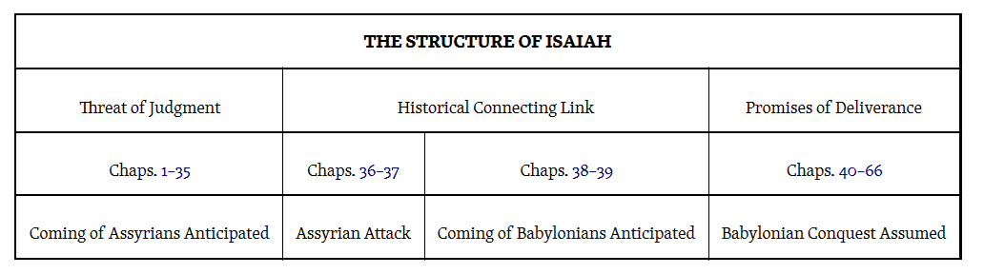

**Key Passage Exegesis**

* An invitation to consider, Isaiah 1:18.
* A vision of the Lord’s holiness, Isaiah 6.
* The virgin birth, Isaiah 7:14.
* Standard for evaluating preachers, Isaiah 8:20.
* The Child’s coming kingdom, Isaiah 9:1-7.
* The Son of Jesse’s kingdom, Isaiah 11:1-16.
* Judgement of the King of Babylon, Isaiah 14.
* Isaiah’s apocalypse, Isaiah 24-27.
* Armageddon and the Kingdom, Isaiah 34-35.
* Waiting for the Lord, Isaiah 40:27-31.
* Cyrus will rebuild the city and the temple, Isaiah 44:28.
* The suffering and triumph of the Servant, Isaiah 52:13-53.
* The Gospel according to Isaiah, Isaiah 55:1-13.
* Kingdom rebuilding of the earth and the scary place, Isaiah 66:22-24.

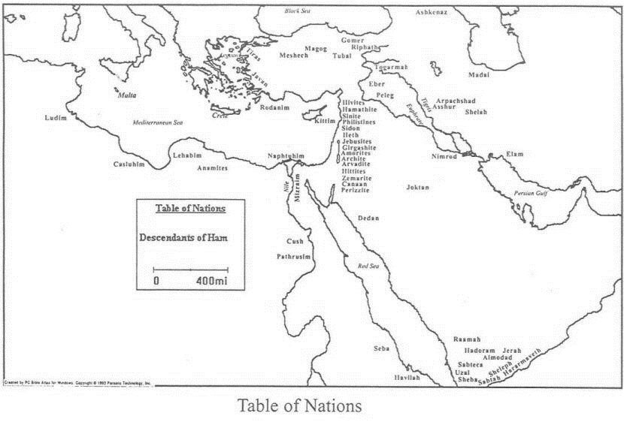

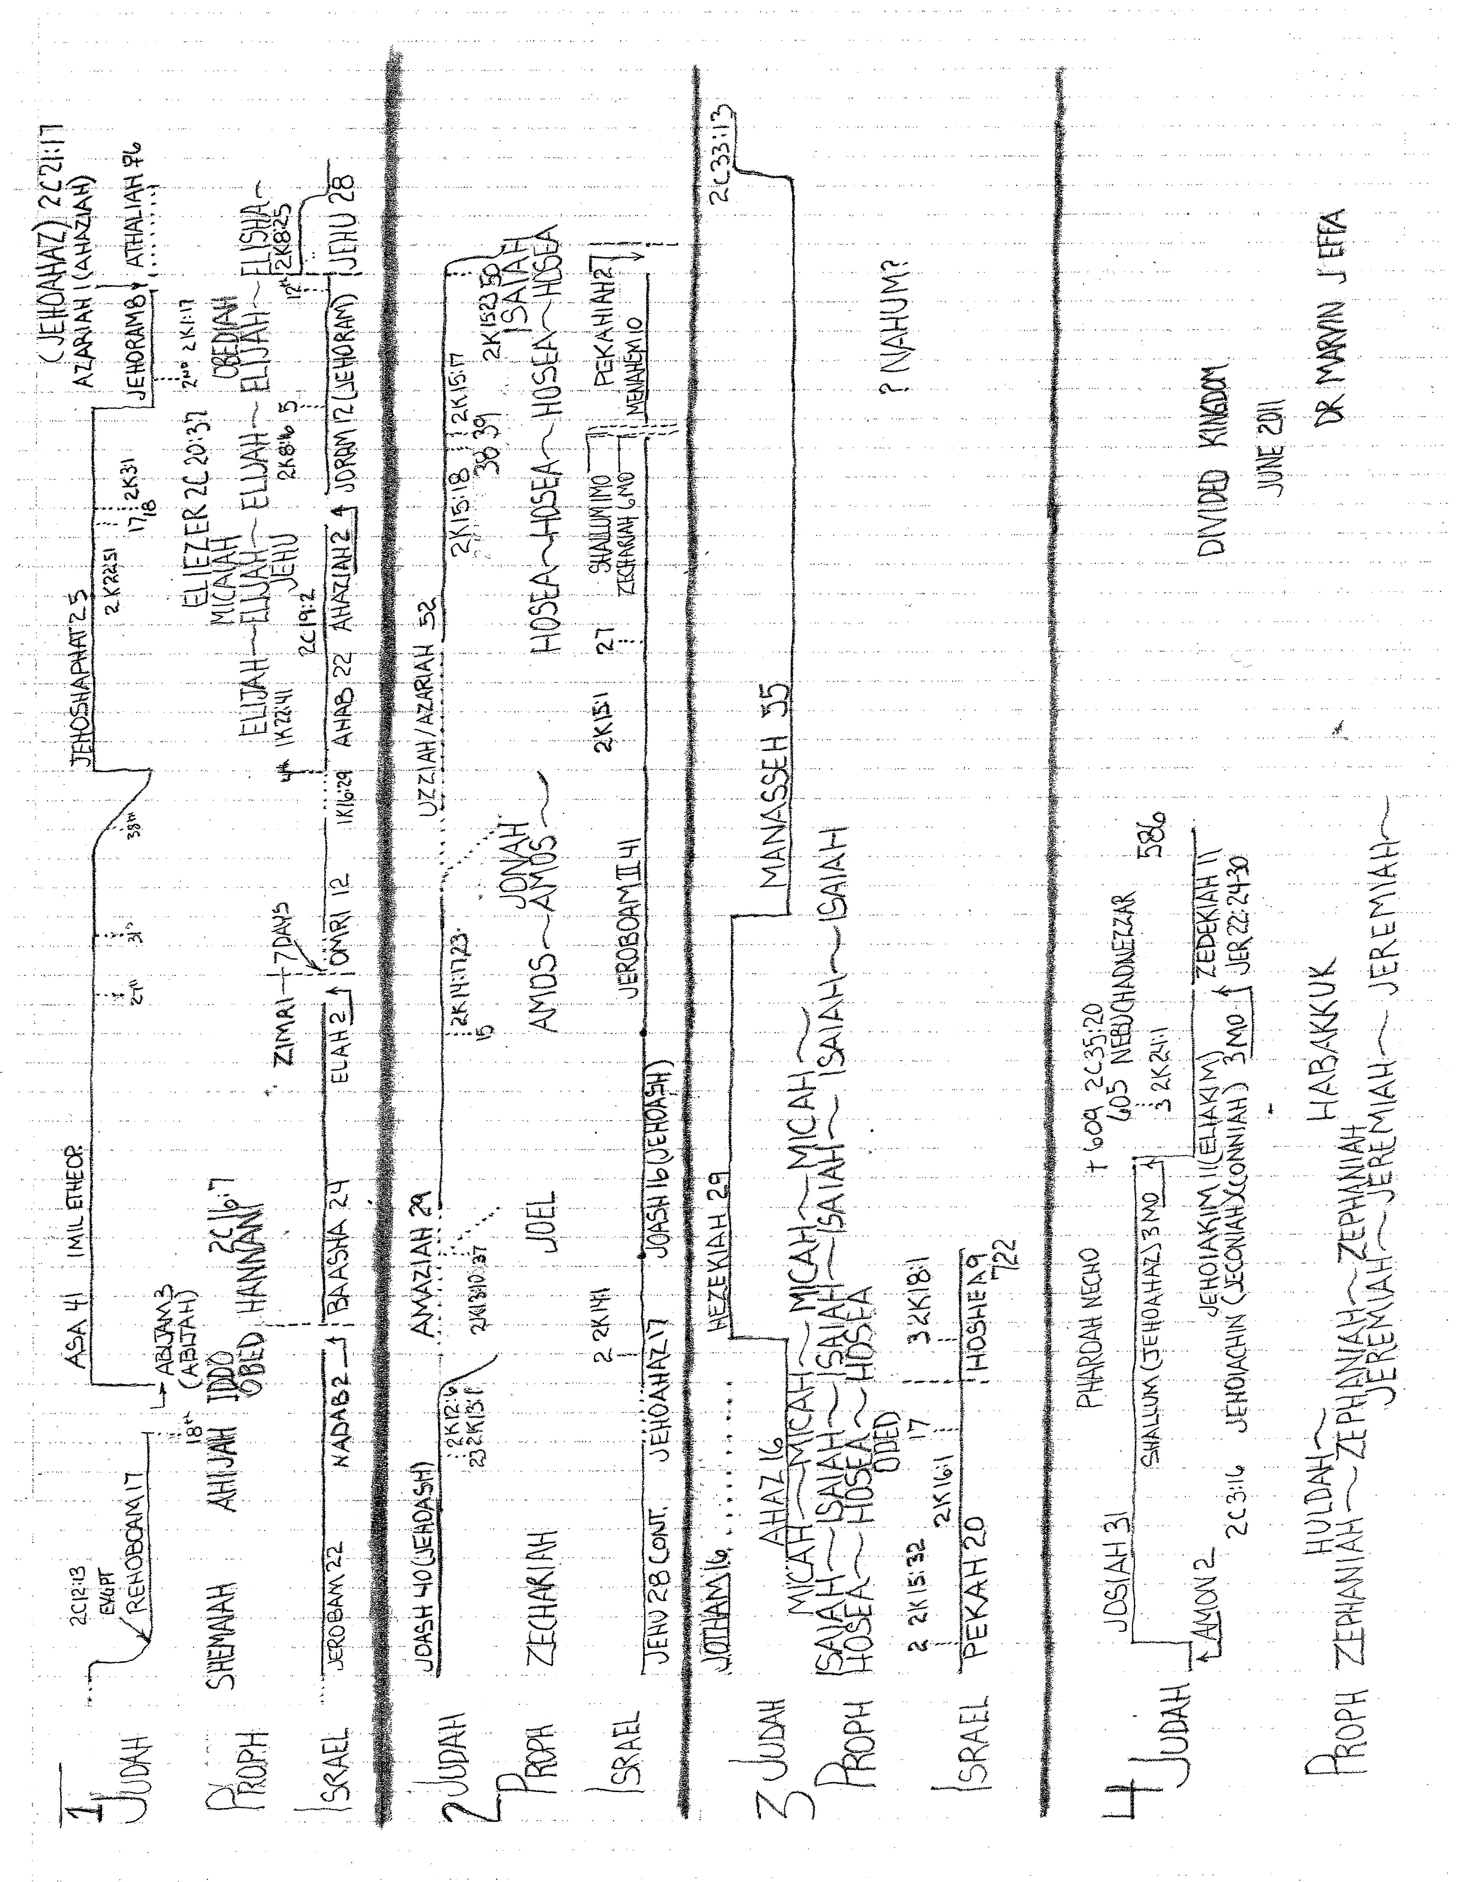

1. G. Michael Cocoris, 2016 Euclid #20, Santa Monica, CA 90405, *The Bible: Book by Book*, 2000, internet paper.